Software Requirements Specification

for

Learn C

Version 1.0 approved

Prepared by

Showmik, MD. Jannatul Baki 15-28584-1

Poddar, Sourav 15-28968-1

Yeasmin, Tamanna 14-26653-2

Sonok borshan sarker  14-27646-3

Table of Contents

Table of Contents ii

Revision History Error! Bookmark not defined.

1. Introduction 3

1.1 Purpose 3

1.2 Document Conventions 3

1.3 Intended Audience and Reading Suggestions 3

1.4 Project Scope 3

1.5 References **Error! Bookmark not defined.**

2. Overall Description 3

2.1 Product Perspective 3

2.2 Product Features 3

2.3 User Classes and Characteristics 3

2.4 Operating Environment 4

2.5 Design and Implementation Constraints 4

2.6 User Documentation **Error! Bookmark not defined.**

2.7 Assumptions and Dependencies **Error! Bookmark not defined.**

3. System Features Error! Bookmark not defined.

3.1 System Feature 1 **Error! Bookmark not defined.**

4. Other Nonfunctional Requirements 4

4.1Safety Requirements 4

# Introduction

## Purpose

The aim of this document is to specify the requirements of the software “Learn C”. ”Learn C” is a new software geared to the people who has an interest in programming language .

## Document Conventions

Flowing conventions are followed in this document:

* Class names are in Italic form and enclosed in double quote.
* Topic names are in small letter.
* Every Topic have own priorities .

## Intended Audience and Reading Suggestions

This document is intended for developers

## Project Scope

“Learn C” is mainly education site software. The purpose of this software is to help its users to learn basic programming language.

The main task of this software is to take input of user for registration and after completing registration user have to login with username and password then new window will come up.

In this window different chapter will be included part by part. After completing one chapter (i.e: Array) user can participate in quiz session.

# Overall Description

## Product Perspective

The Idea is to make a software that would help to learn basic C programming language . At 1st user have to login if user have existing account .The account could be edited at any time .The lesson of C will be in different steps and there will be some test/quiz that are mandatory to complete to go to next lesson. After completing the whole course, the user will be rewarded .

## Product Features

Here individual lesson or chapter is the main features of this software

## User Classes and Characteristics

Those people who has interest in programming language are the main target user of this application.

## Operating Environment

This software will be used in desktop .

## Design and Implementation Constraints

As we program the software parallel it can run any kind of processing system like duel core, core i3.

As much as the application will get higher configuration, application will perform more smoothly

**Initial design:**

**Use-case diagram**

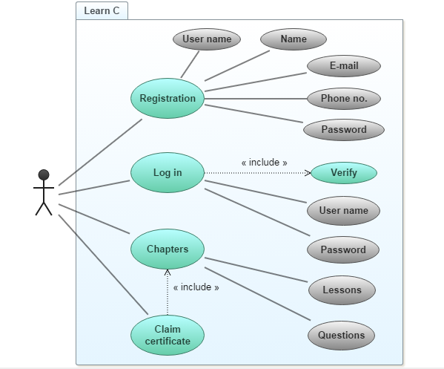

**Class diagram**

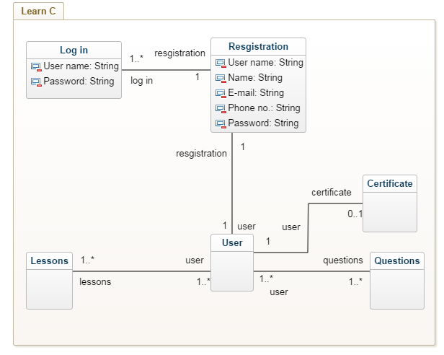

**Activity diagram**

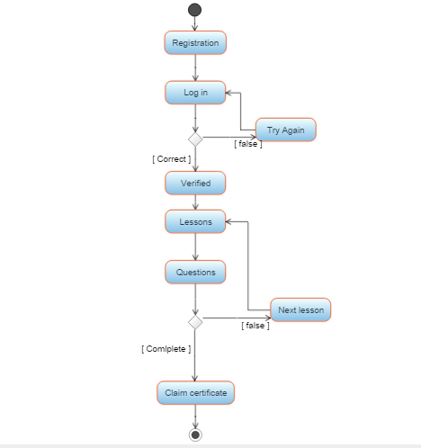

**Er-diagram**

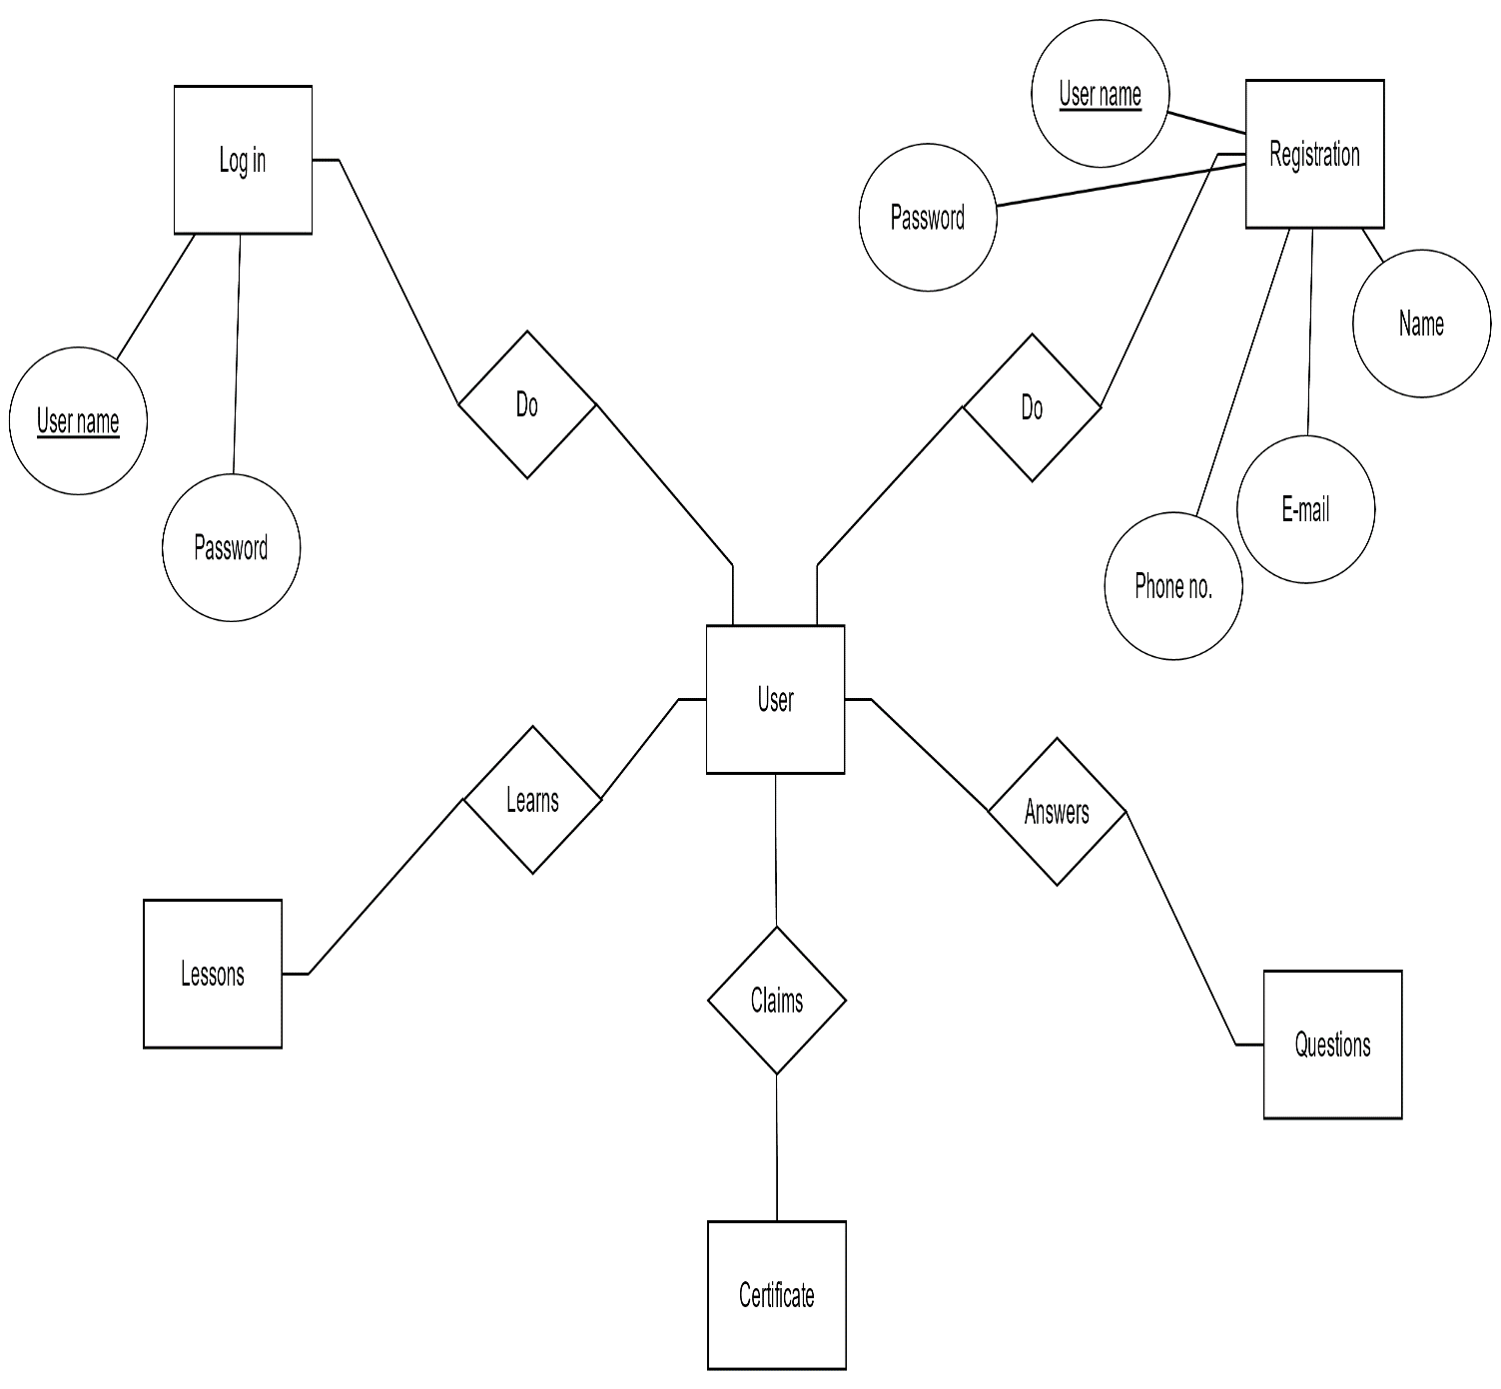

## 2.6 Assumptions and Dependencies : There is no assumed factors which can affect the requirements state in the SRS

# 3.System Features

In this system each chapter or lessons is the main features .

Chapter 1(Basic concept)

3.1.1 Description and Priority

Chapter 1 or lesson 1 is most important because after completing 1st chapter user can open chapter 2 otherwise not

3.1.2 Stimulus/Response Sequences

User just need to login for opening the chapter or lessons

3.1.3 Functional Requirements

For this features application does not need any additional facilities like internet connection or something else

REQ-1:

REQ-2:

# Other Nonfunctional Requirements

## 4.1Safety Requirements

In this app there is no safety Requirements .This is desktop application ,so his/her desktop or computer lock is the main security.